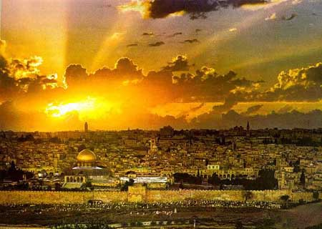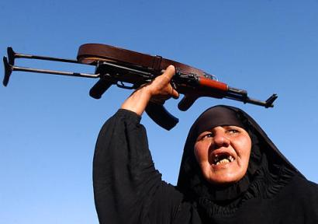

**CARD D: History**

Understanding History helps our understanding of change and continuity. Indeed one cannot fully understand the world today without an understanding of History and events like the Crusades.

**CARD C: Change and Continuity**

As with all major events throughout History the Crusades experienced both change and continuity. For example ideas spread and Jerusalem continues to be important to Christianity, Islam and Judaism.

**CARD B: Everything Changed**

The Crusades did not only differ from one another but the Crusades greatly influenced Europe and the Holy Land. Indeed this is why we still see the words Crusade and Jihad in the news today,

**CARD A: No Change**

All the Crusades were very similar with no real change. Things stayed the same. The Crusades had little influence on Europe and the Holy Land.